**Transition – A Parent’s Guide**

**The Facts**

Only share the facts needed with your child/ children –Anxieties maybe heightened at this time, what information is/ is not helpful to share?

**School**

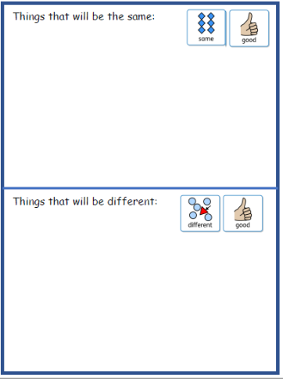Gather information – your child/ children’s school, will provide the information relevant to their plan for their setting - this may include:

1. Routine
2. Staffing
3. Classrooms
4. Resources
5. Equipment
6. Travel
7. Lunches

**Sharing Information**

There may have been a number of changes that have happened since schools closed for the majority of pupils in March.

It may be important to share changes with school

* Family circumstances
* Health – mental and physical
* Behaviours
* Bereavement and loss

Also, let the school know what has/has not work well at home.

**Supporting transition back into school**

* Look at the school’s website – re-familiarise your child/ children with the staff and their school setting
* 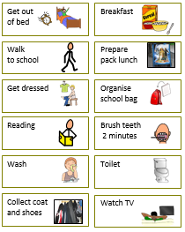 Talk about school – does your child/ children express any concerns or worries
* Use a calendar to count down days left to return to school

* Begin to reintroduce a school morning routine
* Be prepared - packed lunches, uniform, equipment, travel, change
* What resources may help? – visual charts, stories (ask your school)

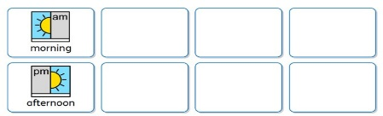

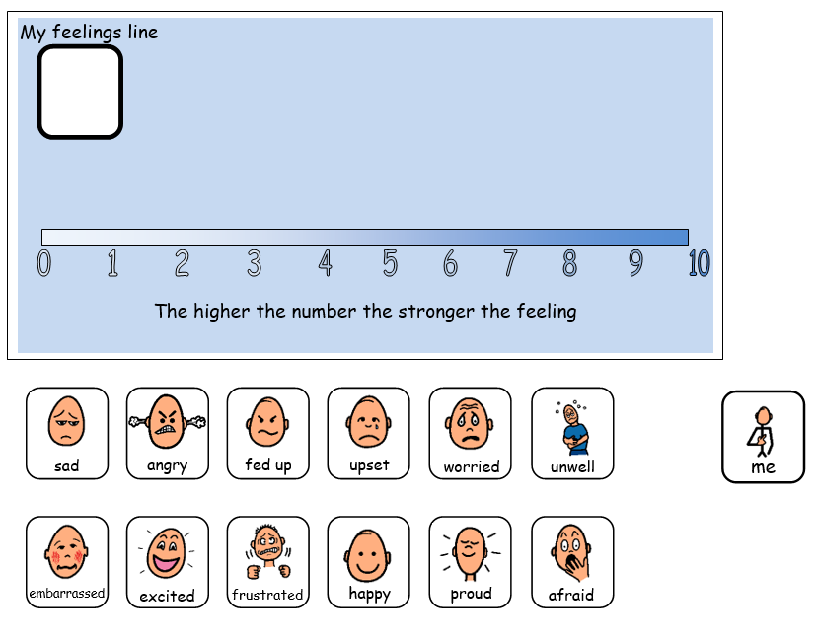

**Ideas for managing anxieties**

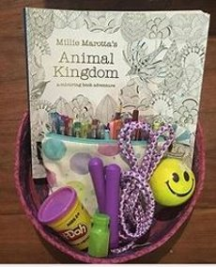

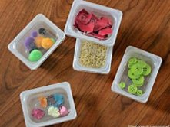

**Calming box**

Colouring, physical exercise, blowing bubbles/ feathers – can help children to self-regulate when their emotions are heightened. A calming box can be inexpensive and often these items can be already found I the home

**Yoga**

****Supports physical and mental relaxation, yoga supports calmness using breathing and movement.

https://www.youtube.com/user/CosmicKidsYoga/playlists

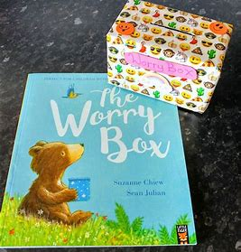

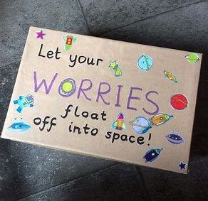

**Worry box**

Creating a box to store and put away worries is a good way for children to manage stressful times. Children can write/ draw their worries and then put them away in the box. These can be looked at by an adult or revisited by the child.

[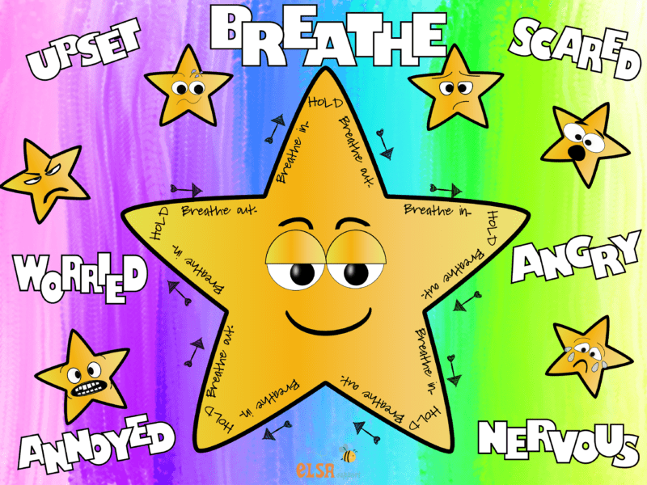](https://www.elsa-support.co.uk/breathing-techniques/)

**Breathing techniques**

Helps to focus and slow breathing down. Breathing exercises help regulation when feeling overwhelmed.

https://www.elsa-support.co.uk/relaxationcalming-activities-children/



**Reading**

Relaxing with a good book, stimulates the brain, reduces anxiety, increases memory.



**Listening to music**

Reduces stress and anxiety, boosts motivation and improves sleep. When choosing music consider the volume, rhythm and content.

**Exercise**

Including physical exercise in the day such as walking, running, cycling can increase self-esteem, improve concentration and support good mental health.



**Connecting with friends and family**

Communicating with others builds self-worth and decreases stress levels. Emotional support can also be given and received.

**Support wellbeing**

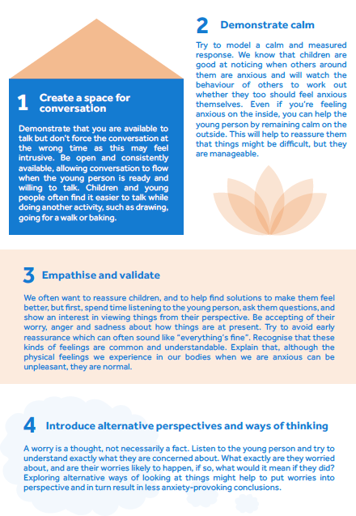



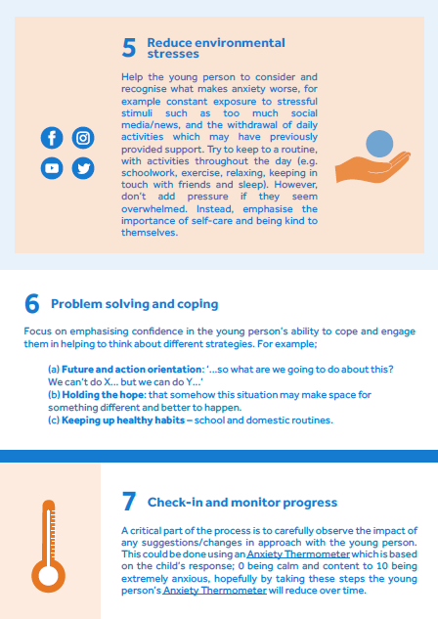

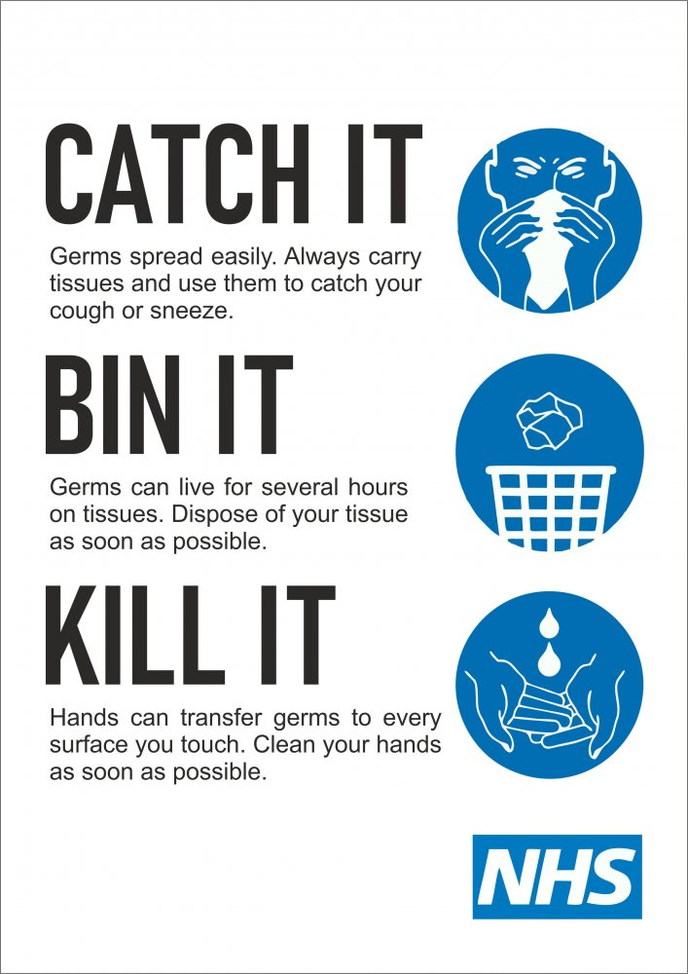**Reinforce hygiene and social distancing**

