
Children & Young People’s Service
Children With Additional Needs
Endeavour House
8 Russell Road
Ipswich IP1 2BX

Suffolk County
Council

Pupil name: Date:

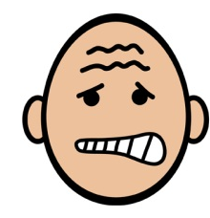

1 2 3 4 5 6 7 8 9 10
Being with my friends
1 2 3 4 5 6 7 8 9 10
Spending time with my friends

1 2 3 4 5 6 7 8 9 10
Lunchtimes – dinner hall
1 2 3 4 5 6 7 8 9 10
Walking around school
1 2 3 4 5 6 7 8 9 10
Break times – being outside
1 2 3 4 5 6 7 8 9 10
Knowing where I am allowed to go

1 2 3 4 5 6 7 8 9 10
Knowing what is expected of me
1 2 3 4 5 6 7 8 9 10
Knowing what to do in lessons
1 2 3 4 5 6 7 8 9 10
Getting into trouble
1 2 3 4 5 6 7 8 9 10
Asking for help
1 2 3 4 5 6 7 8 9 10
Feeling safe in school
1 2 3 4 5 6 7 8 9 10

