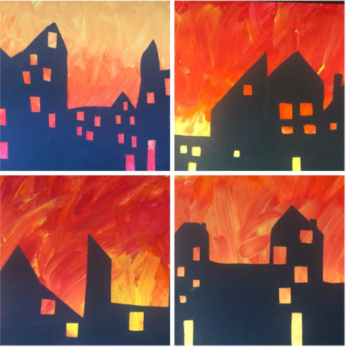

These have been made by painting or colour the background like fire (oranges and reds) and then using black paper to create houses over the top. Please ask if you need any black paper or resources.