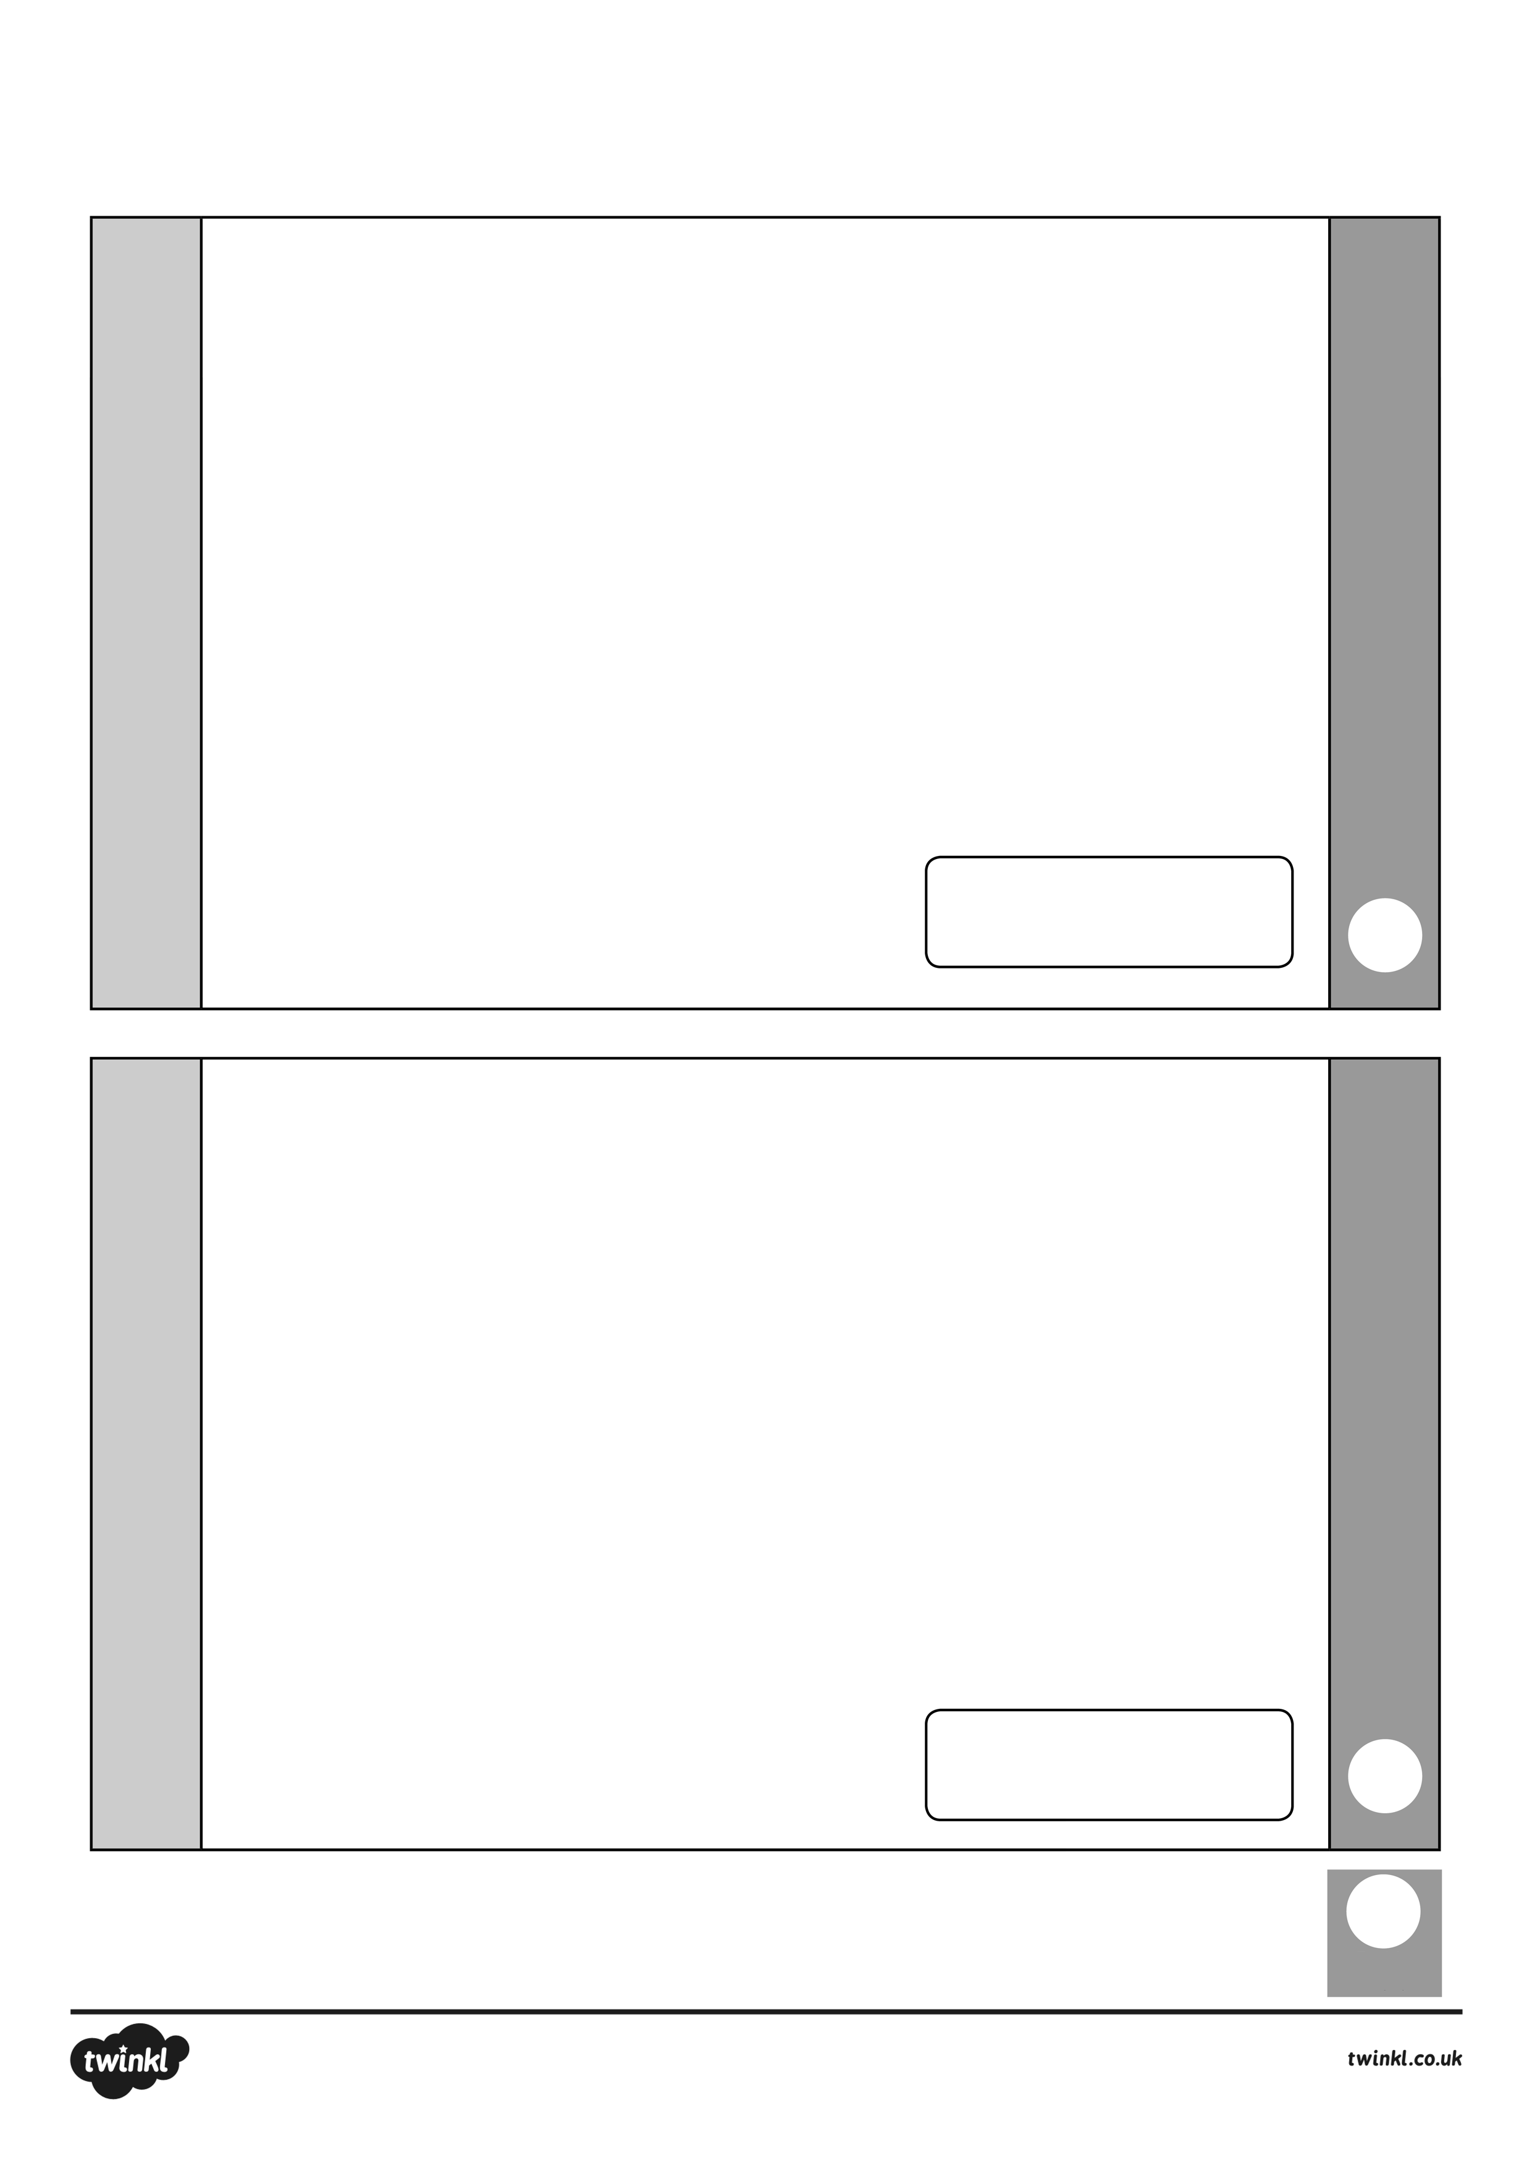

Key Stage 1 Arithmetic Assessment

total

mark

mark

58 + 8 =

79 – 30 =

2

1



mark

mark

total

59 + 24 =

41 + 35 =

4

3



total

mark

mark

5

6

87 – 31 =

50 – 16 =



34 + _ = 72

8

7

_ + 25 = 67



_ - 15 = 48

9

83 - _ = 33

10