Maths | Science | English
Arithmetic  TIMES TABLES PRACTISE – e.g. Rockstars  - Complete one of the Year 4 maths mats- Choose from 1,2 or 3 star.  - Complete the arithmetic challenge.  - Find some key dates in Anglo Saxon history and use these numbers to create some addition and subtraction calculations (don’t forget to tell us why the dates are important!). | - WITH A GROWN UP TO HELP, break open an egg and then cook it. Draw diagrams to show when it changes state (ie. When is it liquid? When is it solid? Do you see any form of gas?).  - List as many food items as you can that change from a solid to a liquid when heated.  - Show, using words or pictures, how the water cycle works. | Reading  READING WITH AN ADULT 3-4 TIMES PER WEEK  - Choose 1 of the Anglo-Saxon reading questions sheets to complete  - When on a journey, see if you can read the road signs and spot any Anglo-Saxon names, write them down and then try to find an interesting fact about that place.
Reasoning  - Use key dates to create a chronological timeline (you could use dates from your own life timeline).  - Complete the reasoning questions sheet | Year 4 – Autumn 2024  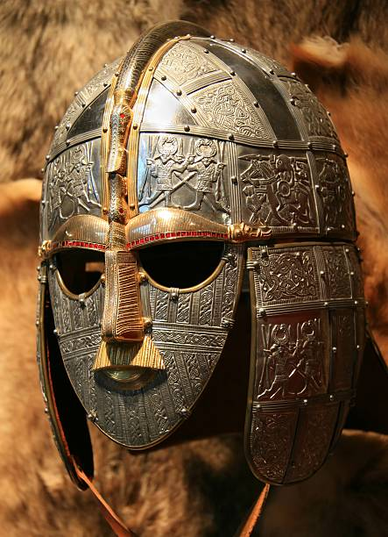  Anglo Saxons  BOLD home learning should be completed EVERY WEEK.  Pick one other task from the grid each week.  Tasks in the ‘Topic’ section should only be completed once per half term. | SPaG  PRACTISING SPELLINGS  - Imagine you are an Anglo Saxon travelling to Britain and write a diary of your journey (Why are you travelling? Who are you with? What is the journey like?).  - Make an index of Anglo Saxon place names and put them all in alphabetical order – try to include at least 15 place names.  - Create 10 silly sentences using as many of the Year 3 and 4 words from the word list
Topic
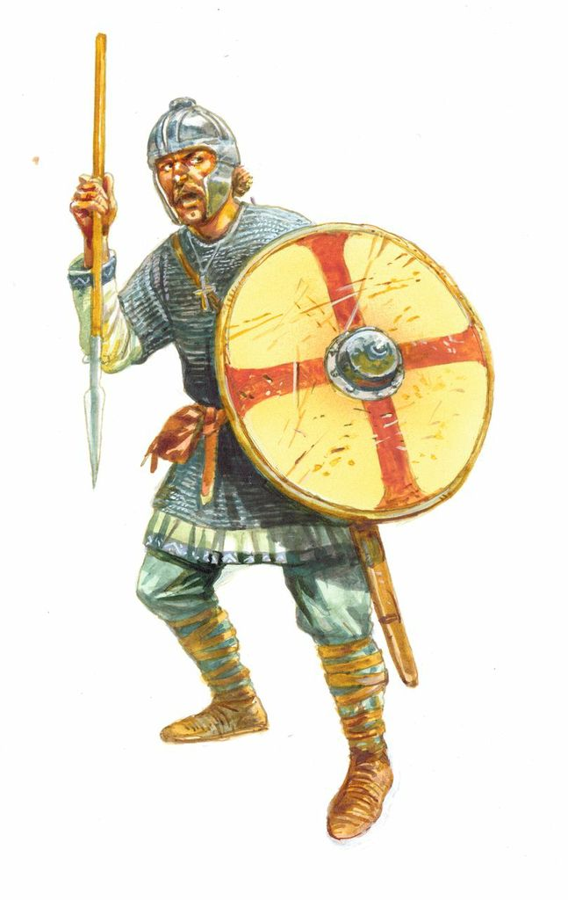
- Find out about a modern day town or city that has evidence of Anglo Saxon settlement. What is the place like now? What did they find there to show Anglo Saxons had been there?
- Using a map of Europe, show different routes the Angles, Saxons and Jutes may have taken to get to Britain by land and sea.
- Make an information page about an Anglo Saxon village including labelled diagrams and fact boxes.
- Make a 3D Anglo- Saxon inspired helmet using junk modelling
- Find out about what Anglo-Saxons enjoyed to eat. Create a menu for them to enjoy.

