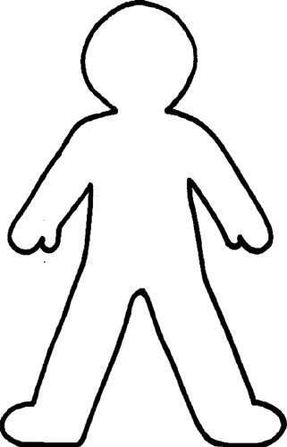

Autumn

Winter

Summer

Spring