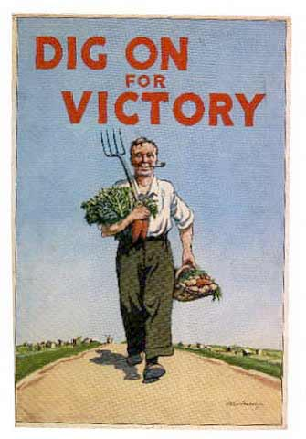
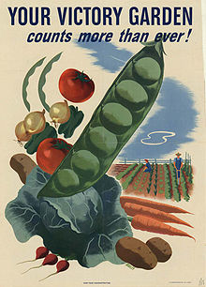
VICTORY GARDENS


During World War 2, a garden was a useful thing to have. Because of rationing, food was in short supply. Flowers grown for decoration were replaced by vegetables that could provide extra food for the family.
Your job is to draw up a plan of your Victory Garden. You have to dig up the grass and make your garden do some work! Your garden is 10m by 14m. You must have paths 1 metre wide between all the different areas in your garden.

In your garden you will need:

 | Size | Amount of wood needed * (if relevant)
Anderson Shelter | 2m wide x 3m long
Vegetable allotment | As large a space as possible
Fruit trees | Each tree needs 6 sq metres
Compost Heap * | 1m x 2m
Greenhouse | 1.8m wide x 2.5m long
Chicken coop * | 1 sq metre per chicken
Rabbit hutches *  (can be built up like a block of flats, to a maximum of 3 storeys) | 0.5 sq metre per rabbit

If you finish your plan, use books to research which vegetables you would grow, and put them on your plan in the vegetable allotment.

