Hands!

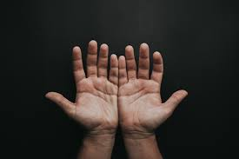

Your hands are amazing

Have a look at your hands.

Can you wriggle your fingers?

Open and shut your fingers?

Can you make a fist nice and tight?

Can you touch your thumb to each of your fingertips?

What different shapes can you make with your hands and your fingers?

This is a version of the alphabet using your fingers on one hand.

Can you copy them on one hand? Now try the other hand.

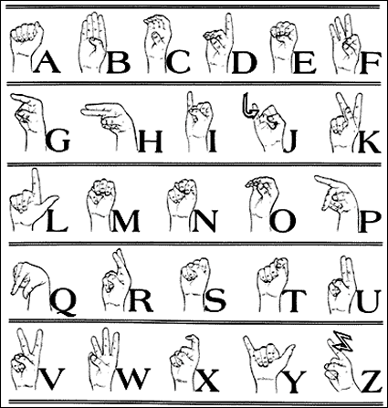

Other fun hand activities to try are:

* picking up small objects and putting them in a pot
* crumpling up a piece of paper in one hand (make sure it’s not being used by someone first!)
* picking up a few coins in one hand and then putting them one by one in a purse or pot
* threading beads onto some string, a lace or a pipe cleaner – whatever you have around the house
* play with playing cards
* tie your shoelaces – you can practice with pipe cleaners to make it easier
* playing with playdough

See what other activities you can find to make your hands and your fingers active and strong.